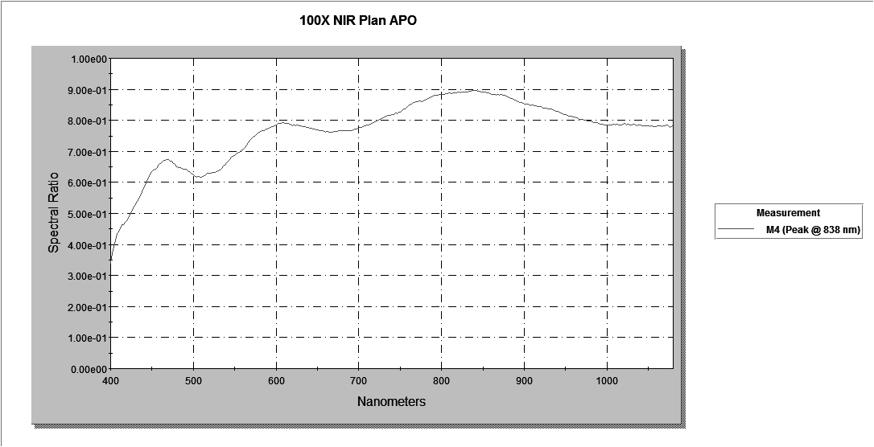

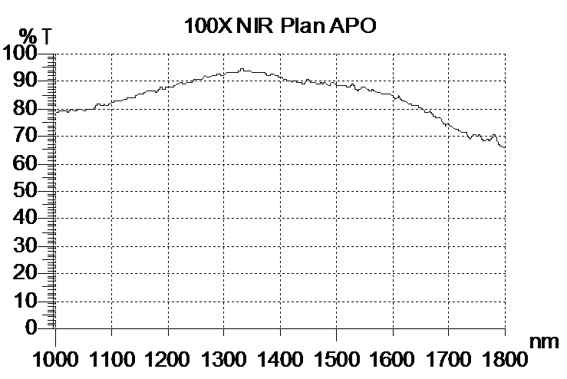
380 | 0.5%
382 | 1.8%
384 | 3.9%
386 | 6.9%
388 | 10.2%
390 | 13.9%
392 | 18.7%
394 | 22.6%
396 | 26.5%
398 | 30.7%
400 | 33.9%
402 | 37.1%
404 | 39.2%
406 | 41.3%
408 | 43.5%
410 | 44.1%
412 | 45.0%
414 | 46.4%
416 | 46.5%
418 | 47.5%
420 | 47.9%
422 | 49.1%
424 | 50.2%
426 | 51.0%
428 | 52.3%
430 | 52.8%
432 | 53.8%
434 | 54.8%
436 | 55.8%
438 | 56.9%
440 | 58.0%
442 | 59.1%
444 | 60.5%
446 | 61.6%
448 | 62.5%
450 | 63.4%
452 | 64.0%
454 | 64.4%
456 | 64.9%
458 | 65.8%
460 | 66.1%
462 | 66.5%
464 | 67.0%
466 | 67.2%
468 | 67.4%
470 | 67.3%
472 | 66.9%
474 | 66.8%
476 | 66.0%
478 | 65.7%
480 | 65.0%
482 | 64.9%
484 | 64.7%
486 | 64.5%
488 | 64.3%
490 | 64.2%
492 | 63.9%
494 | 63.5%
496 | 63.1%
498 | 62.7%
500 | 62.4%
502 | 61.9%
504 | 61.8%
506 | 61.9%
508 | 61.7%
510 | 61.8%
512 | 62.0%
514 | 62.3%
516 | 62.7%
518 | 62.9%
520 | 62.9%
522 | 63.1%
524 | 63.1%
526 | 63.2%
528 | 63.4%
530 | 63.7%
532 | 64.1%
534 | 64.6%
536 | 65.2%
538 | 65.6%
540 | 66.2%
542 | 66.9%
544 | 67.4%
546 | 68.0%
548 | 68.5%
550 | 68.7%
552 | 69.1%
554 | 69.4%
556 | 69.7%
558 | 70.1%
560 | 70.5%
562 | 71.2%
564 | 72.0%
566 | 72.7%
568 | 73.5%
570 | 74.0%
572 | 74.5%
574 | 75.0%
576 | 75.5%
578 | 75.8%
580 | 76.2%
582 | 76.4%
584 | 76.6%
586 | 76.7%
588 | 77.1%
590 | 77.3%
592 | 77.4%
594 | 77.7%
596 | 78.0%
598 | 78.2%
600 | 78.6%
602 | 79.0%
604 | 79.0%
606 | 79.1%
608 | 79.2%
610 | 79.1%
612 | 79.1%
614 | 78.9%
616 | 78.8%
618 | 78.5%
620 | 78.3%
622 | 78.4%
624 | 78.3%
626 | 78.4%
628 | 78.1%
630 | 78.1%
632 | 78.0%
634 | 77.9%
636 | 77.8%
638 | 77.7%
640 | 77.4%
642 | 77.5%
644 | 77.3%
646 | 77.3%
648 | 77.0%
650 | 76.9%
652 | 76.7%
654 | 76.7%
656 | 76.6%
658 | 76.4%
660 | 76.3%
662 | 76.3%
664 | 76.3%
666 | 76.1%
668 | 76.3%
670 | 76.5%
672 | 76.5%
674 | 76.5%
676 | 76.8%
678 | 76.7%
680 | 76.8%
682 | 76.8%
684 | 76.7%
686 | 76.6%
688 | 76.8%
690 | 76.7%
692 | 76.8%
694 | 76.9%
696 | 77.1%
698 | 77.3%
700 | 77.5%
702 | 77.7%
704 | 77.7%
706 | 78.1%
708 | 78.2%
710 | 78.5%
712 | 78.6%
714 | 78.8%
716 | 79.1%
718 | 79.3%
720 | 79.5%
722 | 79.8%
724 | 80.1%
726 | 80.3%
728 | 80.7%
730 | 81.0%
732 | 81.1%
734 | 81.3%
736 | 81.6%
738 | 81.7%
740 | 81.8%
742 | 82.0%
744 | 82.3%
746 | 82.2%
748 | 82.7%
750 | 82.7%
752 | 83.2%
754 | 83.6%
756 | 83.8%
758 | 84.3%
760 | 84.8%
762 | 85.0%
764 | 85.3%
766 | 85.6%
768 | 85.8%
770 | 85.9%
772 | 86.0%
774 | 86.2%
776 | 86.1%
778 | 86.3%
780 | 86.5%
782 | 86.7%
784 | 86.9%
786 | 87.2%
788 | 87.5%
790 | 87.8%
792 | 88.0%
794 | 88.0%
796 | 88.2%
798 | 88.3%
800 | 88.4%
802 | 88.5%
804 | 88.5%
806 | 88.6%
808 | 88.7%
810 | 88.8%
812 | 88.7%
814 | 88.7%
816 | 88.9%
818 | 88.9%
820 | 89.0%
822 | 88.9%
824 | 89.0%
826 | 89.1%
828 | 89.1%
830 | 89.2%
832 | 89.2%
834 | 89.3%
836 | 89.4%
838 | 89.7%
840 | 89.5%
842 | 89.5%
844 | 89.5%
846 | 89.4%
848 | 89.1%
850 | 89.1%
852 | 89.0%
854 | 88.8%
856 | 88.8%
858 | 88.5%
860 | 88.3%
862 | 88.2%
864 | 88.3%
866 | 88.2%
868 | 88.3%
870 | 88.2%
872 | 88.2%
874 | 88.1%
876 | 88.0%
878 | 87.8%
880 | 87.6%
882 | 87.3%
884 | 87.1%
886 | 86.7%
888 | 86.5%
890 | 86.2%
892 | 86.0%
894 | 85.8%
896 | 85.7%
898 | 85.5%
900 | 85.3%
902 | 85.3%
904 | 85.2%
906 | 85.0%
908 | 84.8%
910 | 84.9%
912 | 84.8%
914 | 84.6%
916 | 84.6%
918 | 84.5%
920 | 84.3%
922 | 84.1%
924 | 84.0%
926 | 83.8%
928 | 83.8%
930 | 83.6%
932 | 83.7%
934 | 83.5%
936 | 83.2%
938 | 83.0%
940 | 82.9%
942 | 82.6%
944 | 82.4%
946 | 82.1%
948 | 82.0%
950 | 81.8%
952 | 81.5%
954 | 81.4%
956 | 81.3%
958 | 81.2%
960 | 81.0%
962 | 80.8%
964 | 80.7%
966 | 80.4%
968 | 80.4%
970 | 80.3%
972 | 80.1%
974 | 80.1%
976 | 79.9%
978 | 79.7%
980 | 79.8%
982 | 79.6%
984 | 79.3%
986 | 79.2%
988 | 79.2%
990 | 79.1%
992 | 78.7%
994 | 78.8%
996 | 78.6%
998 | 78.5%
1000 | 78.6%

1005 | 79.0%
1010 | 79.2%
1015 | 79.4%
1020 | 79.1%
1025 | 79.2%
1030 | 79.9%
1035 | 79.1%
1040 | 79.8%
1045 | 80.1%
1050 | 79.3%
1055 | 79.7%
1060 | 80.0%
1065 | 79.8%
1070 | 80.6%
1075 | 81.5%
1080 | 81.3%
1085 | 81.3%
1090 | 81.2%
1095 | 81.3%
1100 | 82.1%
1105 | 82.7%
1110 | 83.2%
1115 | 83.0%
1120 | 83.2%
1125 | 83.8%
1130 | 84.0%
1135 | 84.2%
1140 | 84.2%
1145 | 84.9%
1150 | 85.5%
1155 | 85.6%
1160 | 86.1%
1165 | 86.7%
1170 | 86.7%
1175 | 86.4%
1180 | 86.3%
1185 | 87.3%
1190 | 87.6%
1195 | 87.4%
1200 | 87.8%
1205 | 87.6%
1210 | 88.1%
1215 | 88.7%
1220 | 89.3%
1225 | 89.4%
1230 | 89.2%
1235 | 89.4%
1240 | 89.6%
1245 | 90.4%
1250 | 91.0%
1255 | 90.7%
1260 | 90.7%
1265 | 91.8%
1270 | 91.6%
1275 | 91.5%
1280 | 91.9%
1285 | 92.0%
1290 | 92.9%
1295 | 92.1%
1300 | 92.2%
1305 | 93.2%
1310 | 93.5%
1315 | 93.3%
1320 | 93.0%
1325 | 93.6%
1330 | 94.5%
1335 | 94.2%
1340 | 93.8%
1345 | 94.0%
1350 | 93.4%
1355 | 93.4%
1360 | 93.5%
1365 | 93.5%
1370 | 93.4%
1375 | 92.5%
1380 | 92.3%
1385 | 92.8%
1390 | 92.4%
1395 | 91.9%
1400 | 91.7%
1405 | 91.1%
1410 | 90.6%
1415 | 90.5%
1420 | 89.9%
1425 | 90.3%
1430 | 90.1%
1435 | 89.8%
1440 | 89.1%
1445 | 89.7%
1450 | 90.8%
1455 | 89.4%
1460 | 89.7%
1465 | 89.0%
1470 | 89.3%
1475 | 89.3%
1480 | 89.5%
1485 | 88.5%
1490 | 89.1%
1495 | 89.6%
1500 | 88.8%
1505 | 88.5%
1510 | 88.5%
1515 | 88.6%
1520 | 87.8%
1525 | 88.2%
1530 | 88.8%
1535 | 87.1%
1540 | 86.9%
1545 | 87.7%
1550 | 87.8%
1555 | 87.1%
1560 | 86.7%
1565 | 87.0%
1570 | 86.3%
1575 | 86.2%
1580 | 85.5%
1585 | 85.5%
1590 | 85.3%
1595 | 85.2%
1600 | 84.6%
1605 | 83.8%
1610 | 84.5%
1615 | 83.5%
1620 | 83.0%
1625 | 82.3%
1630 | 81.5%
1635 | 81.4%
1640 | 81.1%
1645 | 81.1%
1650 | 80.3%
1655 | 80.0%
1660 | 78.5%
1665 | 78.9%
1670 | 78.4%
1675 | 77.2%
1680 | 76.6%
1685 | 76.7%
1690 | 74.6%
1695 | 74.1%
1700 | 74.1%
1705 | 73.7%
1710 | 72.8%
1715 | 72.5%
1720 | 71.9%
1725 | 71.2%
1730 | 71.3%
1735 | 70.0%
1740 | 69.3%
1745 | 70.7%
1750 | 70.3%
1755 | 70.6%
1760 | 69.0%
1765 | 68.6%
1770 | 68.6%
1775 | 68.8%
1780 | 70.5%
1785 | 69.0%
1790 | 66.9%
1795 | 66.2%
1800 | 66.1%

